Frederick Kelemen

2715308

09/24/2021

CIS 496 Project 2

Problem 1 Images

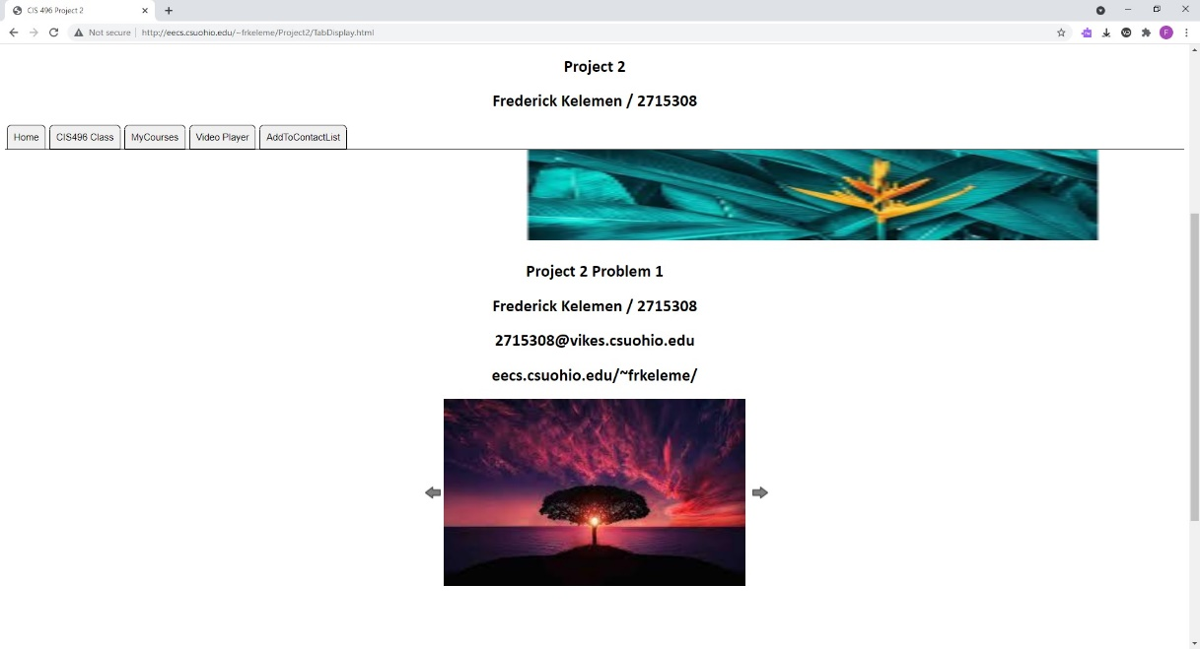

Figure : Problem 1 Home Page First Image

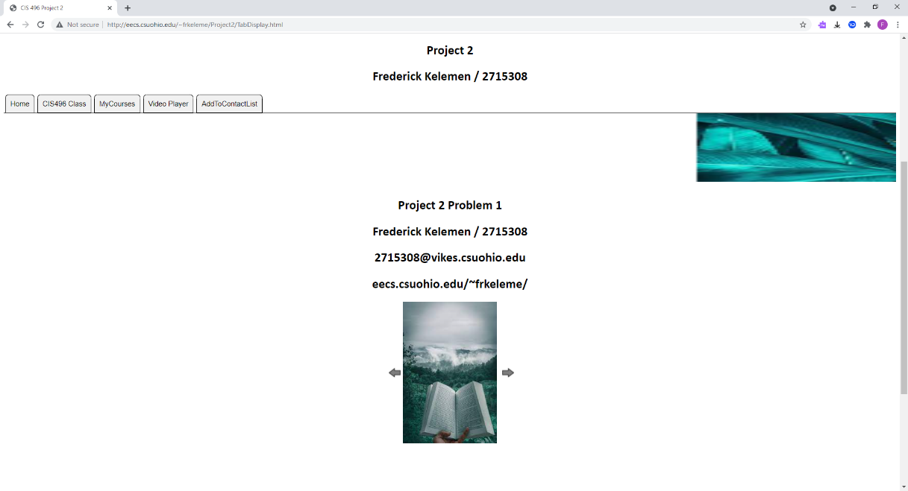

Figure : Problem 1 Home Page Second Image

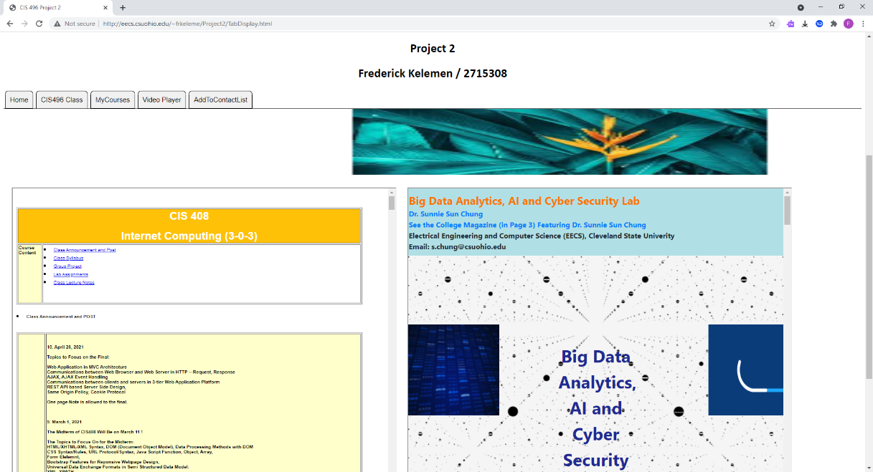

Figure : Problem 1 CIS496 Class Page

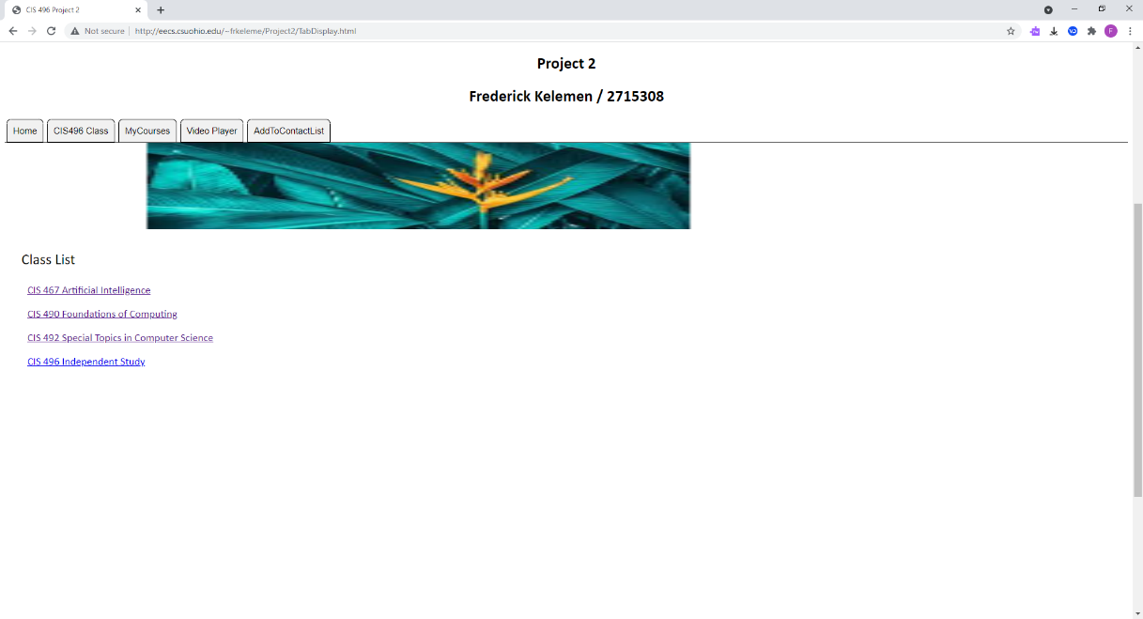

Figure : Problem 1 MyCourses Page

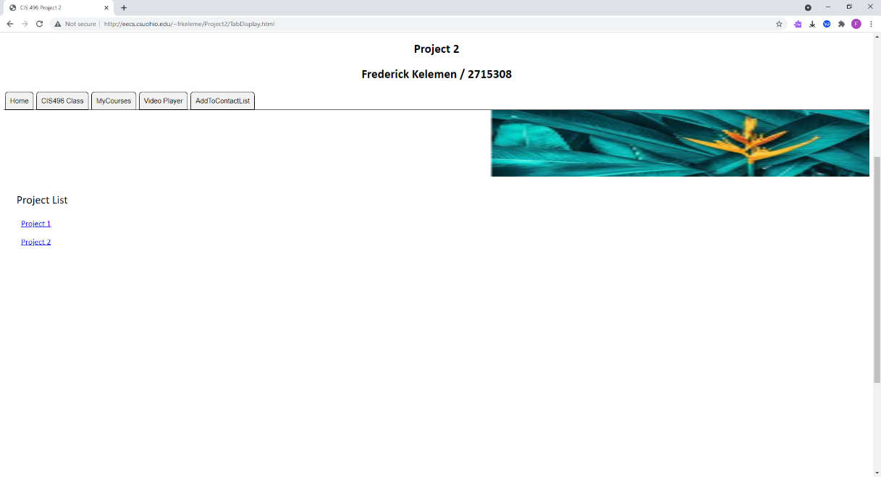

Figure : Problem 1 MyCourses Page, Project Page

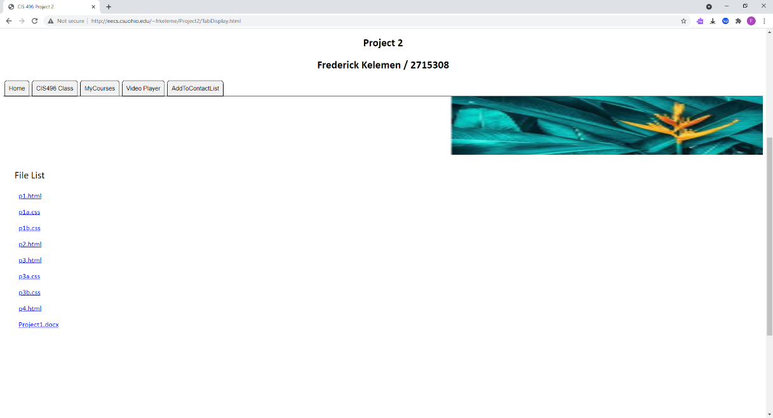

Figure : Problem 1 MyCourses Page, Project 1 Sub Page

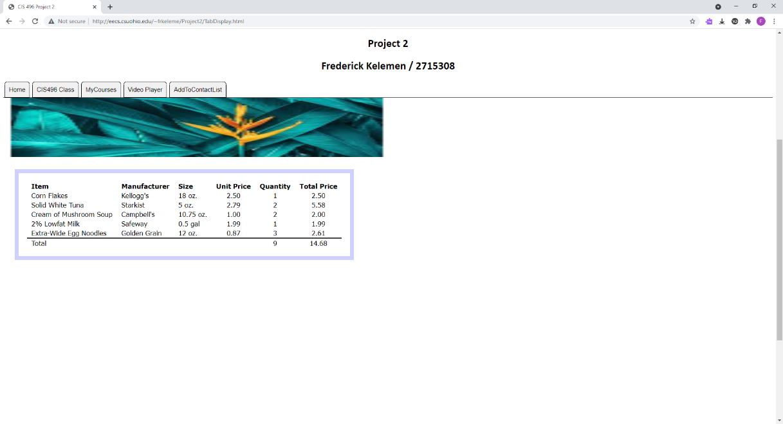

Figure : Problem 1 MyCourses Page, Project 1 Sub Page, p1.html

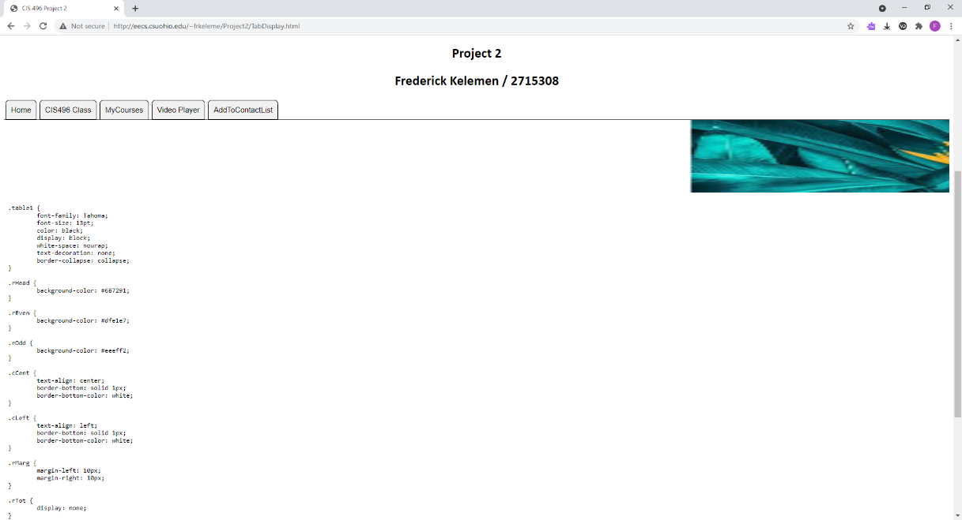

Figure : Problem 1 MyCourses Page, Project 1 Sub Page, p1a.css

Problem 2 Images

Figure : Problem 2 Video Player Page

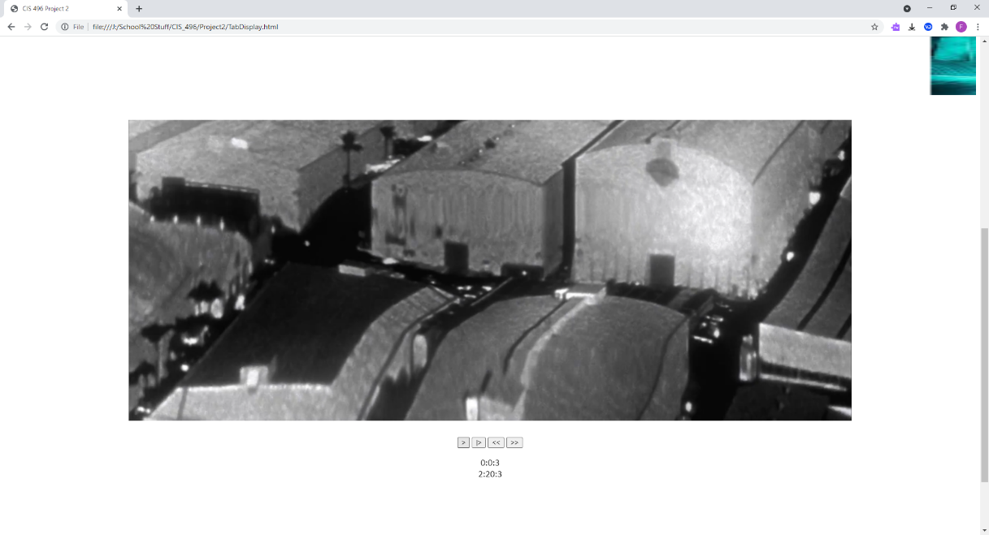

Figure : Problem 2 Video Player Page, Visible Controls

Problem 3 Images

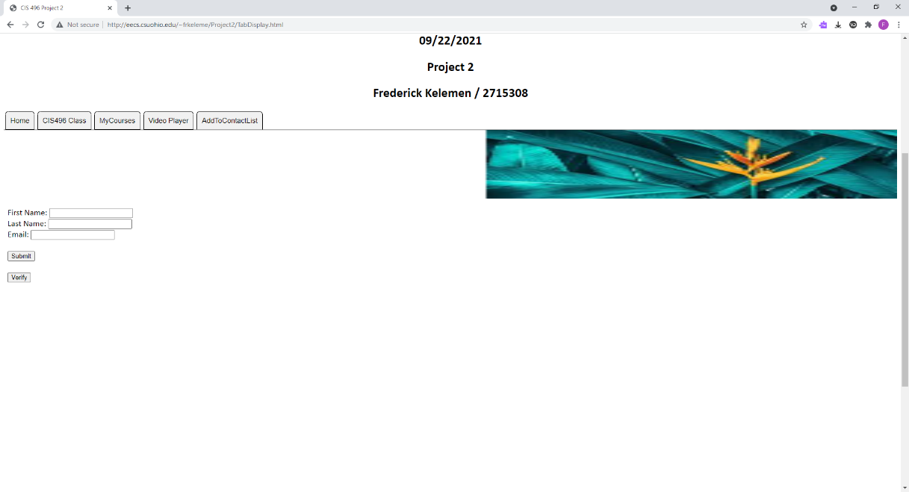

Figure : Problem 3 AddToContactList Page

Figure : Problem 3 AddToContactList Page, Verify, No Slash

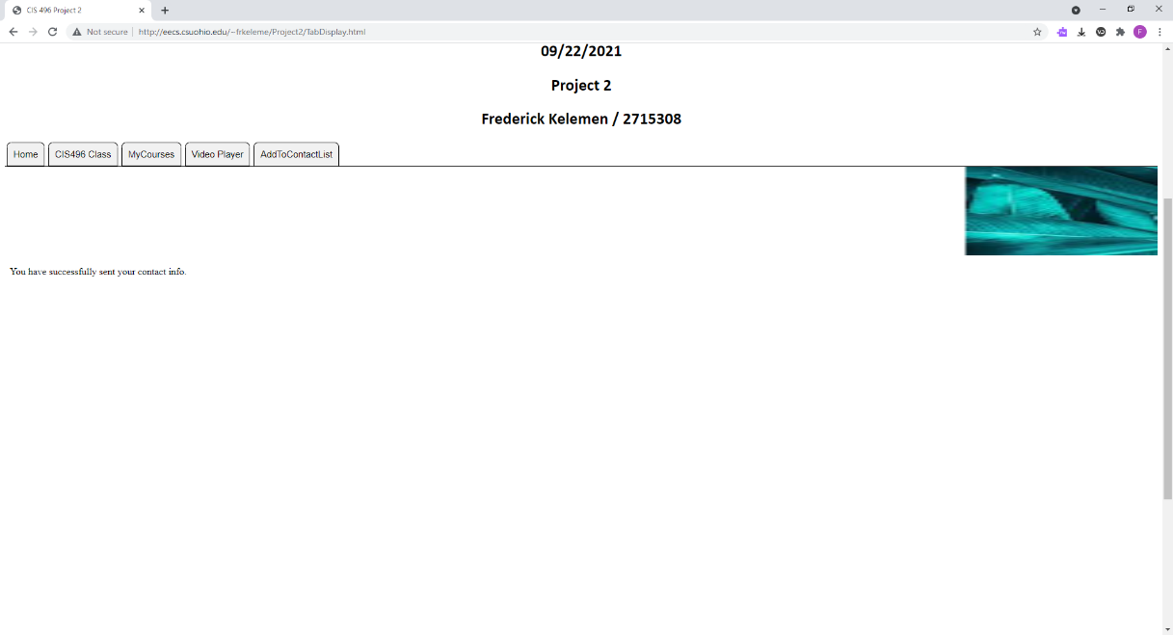

Figure : Problem 3 AddToContactList Page, Confirm, No Slash

Figure : Problem 3 AddToContactList Page, Verify, Slash

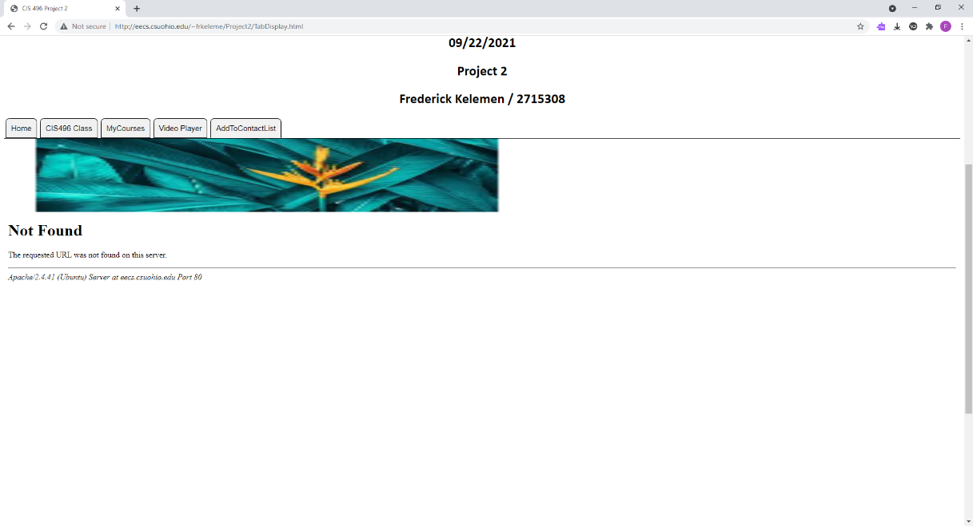

Figure : Problem 3 AddToContactList Page, Confirm, Slash

**TabDisplay.html**

<!DOCTYPE html>

<html lang="en" class="proj2">

<head>

<title>CIS 496 Project 2</title>

<center><p><img src="CSU_Logo.jpg"width="11%"height="20%">

<p><h1>EECS Department</h1>

<p><h1>CIS 496 Independent Study</h1>

<p><h1>Fall 2021</h1>

<p><h2>09/22/2021</h2>

<p><h2>Project 2</h2>

<p><h2>Frederick Kelemen / 2715308</h2></center>

<link rel="stylesheet" href="TabDisplay.css">

<script src="projFunctions.js"></script>

<div class="tab1">

<button type="button" class="tabButton active" onclick="tabFunc(event, 'p1.html')">Home</button>

<button type="button" class="tabButton" onclick="tabFunc(event, 'p2.html')">CIS496 Class</button>

<button type="button" class="tabButton" onclick="tabFunc(event, 'p3.html')">MyCourses</button>

<button type="button" class="tabButton" onclick="tabFunc(event, 'p4.html')">Video Player</button>

<button type="button" class="tabButton" onclick="tabFunc(event, 'p5.html')">AddToContactList</button>

</div>

</head>

<body>

<canvas class="canvas1" id="canvas1">

<img class="img2" src="pic4.jpg" id="img"/>

<script>

var myCanvas = document.getElementById("canvas1");

var myContext = myCanvas.getContext("2d");

var img = document.getElementById('img');

var x = 0;

img.onload = function imgLoad() {

animate();

};

</script>

</canvas>

<iframe scrolling="no" seamless="seamless" id="tabDisplayFrame" src="p1.html" class=frame1 title="Home"></iframe>

</body>

</html>

**TabDisplay.css**

.proj2{

font-size: 18px;

font-family: calibri;

}

.tab1{

overflow: hidden;

border-bottom: 1px solid black;

border-collapse: collapse;

}

.bodyP2 {

display: inline-block;

width: 100%;

height: 100%;

}

.tab1 button {

background-color: #f1f1f1;

float: left;

border: 1px solid black;

padding: 10px;

transition: 0.3s;

font-size: 15px;

margin-left: 3px;

margin-right: 3px;

border-top-left-radius: 15px;

border-top-right-radius: 15px;

border-radius: .5em .5em 0 0;

}

.tab1 button.active {

border-bottom: 1px solid #f1f1f1;

}

.frame1 {

width: 100%;

height: 1000px;

border: none;

}

.frame2 {

width: 45%;

height: 900px;

margin: 10px;

}

.slideShow {

display: inline-block;

height: 300px;

width: 600px;

vertical-align: top;

overflow: visible;

}

.imgButton {

width: 30px;

height: 100%;

border: none;

margin: 2px 2px 1px 1px;

background-color: white;

vertical-align: top;

}

.img1 {

height: 100%;

vertical-align: top;

}

.img2 {

width: 25px;

height: 25px;

vertical-align: center;

}

.header1 {

text-align: left;

margin-left: 20px;

font-size: 25px;

font-style: bold;

}

.list1 {

text-align: left;

margin-left: 30px;

font-size: 18px;

text-decoration: none;

}

.video1 {

vertical-align: top;

width: 75%;

height: auto;

margin: 30px;

}

.vidBtn {

width: 200px;

height: 40px;

opacity: 0;

}

.vidBtn:hover {

opacity: 1;

}

.canvas1 {

width: 100%;

height: 150px;

}

**ProjFunctions.js**

var imgCount = 1;

var plypse = 0;

var started = 0;

function tabFunc(evt, tab) {

document.getElementById('tabDisplayFrame').src=tab;

var tabBtn = document.getElementsByClassName("tabButton");

for(var i=0; i<tabBtn.length; i++) {

tabBtn[i].className = tabBtn[i].className.replace(" active", "");

}

evt.currentTarget.className += " active";

}

function imgFunc(i) {

if (i == 2 && imgCount < 3) {

imgCount++;

} else if (i == 2 && imgCount == 3) {

imgCount = 1;

} else if (i == 1 && imgCount > 1) {

imgCount--;

} else if (i == 1 && imgCount == 1) {

imgCount = 3;

}

document.getElementById('img1').src="pic"+imgCount+".jpg";

}

function vidFunc(evt, i) {

if (i == 1 && plypse == 0 && started == 0) {

plypse = 1;

started = 1;

document.getElementById('vidBtn1').innerHTML = '||';

document.getElementById('vid1').play();

vidStart();

} else if (i == 1 && plypse == 0) {

plypse = 1;

document.getElementById('vidBtn1').innerHTML = '||';

document.getElementById('vid1').play();

} else if (i == 1 && plypse == 1) {

plypse = 0;

document.getElementById('vidBtn1').innerHTML = '>';

document.getElementById('vid1').pause();

} else if (i == 2) {

document.getElementById('vid1').currentTime = 0;

} else if (i == 3) {

document.getElementById('vid1').currentTime -= 10;

} else if (i == 4) {

document.getElementById('vid1').currentTime += 10

}

}

function vidStart() {

setInterval(function vidFunc2() {

var vid = document.getElementById('vid1');

var curTime = vid.currentTime.toFixed(0);

var vidTime = (curTime/3600).toFixed(0) + ':' + ((curTime%3600)/60).toFixed(0) + ':' + (curTime%60).toFixed(0);

var dur = vid.duration.toFixed(0);

var vidDur = (dur/3600).toFixed(0) + ':' + ((dur%3600)/60).toFixed(0) + ':' + (dur%60).toFixed(0);

document.getElementById('vidTime').innerHTML = vidTime;

document.getElementById('vidDuration').innerHTML = vidDur;

}, 500)

}

function myFunction() {

var x = document.getElementById("form1").action;

document.getElementById("demo").innerHTML = x;

}

function formFunc1() {

var fname = document.getElementsByName('fName')[0].value;

var lname = document.getElementsByName('lName')[0].value;

var email = document.getElementsByName('email')[0].value;

var action = document.getElementById('form1').action;

var string = 'fname: ' + fname + '<br> lname: ' + lname + '<br> email: ' + email + '<br>' + action;

document.getElementById('list2').innerHTML = string;

}

function animate() {

x += 1;

myContext.clearRect(0, 0, myCanvas.width, myCanvas.height);

myContext.drawImage(img, x, 0, 145, 145);

window.requestAnimationFrame(animate);

if (x == myCanvas.width)

x = 0;

}

**p1.html**

<!DOCTYPE html>

<html lang="en" class="proj2">

<head>

<meta charset="utf-8">

<title>CIS 496 Project 2 Problem 1</title>

<link rel="stylesheet" href="TabDisplay.css">

<script src="projFunctions.js"></script>

<center>

<p><h2>Project 2 Problem 1</h2>

<p><h2>Frederick Kelemen / 2715308</h2>

<p><h2>2715308@vikes.csuohio.edu</h2>

<p><h2>eecs.csuohio.edu/~frkeleme/</h2>

</center>

</head>

<body>

<center>

<div class="slideShow">

<button type="button" class="imgButton" onclick="imgFunc(1)">

<img class="img2" src="left.jpg"/>

</button>

<img class="img1" src="pic1.jpg" id="img1"></img>

<button type="button" class="imgButton" onclick="imgFunc(2)">

<img class="img2" src="right.jpg"/>

</button>

</div>

</center>

</body>

</html>

**p2.html**

<!DOCTYPE html>

<html lang="en" class="proj2">

<head>

<meta charset="utf-8">

<title>CIS 496 Project 2 Problem 1</title>

<link rel="stylesheet" href="TabDisplay.css">

<script src="projFunctions.js"></script>

</head>

<body>

<div class="bodyP2">

<iframe seamless="seamless" id="newsFrame1" src="http://eecs.csuohio.edu/~sschung/CIS408/CIS408IDS.html" class="frame2"></iframe>

<iframe seamless="seamless" id="newsFrame2" src="http://eecs.csuohio.edu/~sschung/" class="frame2"></iframe>

</div>

</body>

**p3.html**

<!DOCTYPE html>

<html lang="en" class="proj2">

<head>

<meta charset="utf-8">

<meta name="viewport" content="width=device-width, initial-scale=1">

<title>CIS 496 Project 2 Problem 1</title>

<link rel="stylesheet" href="TabDisplay.css">

<script src="projFunctions.js"></script>

</head>

<body>

<div class="header1">

<p>Class List</p>

</div>

<div class="list1">

<p><a href="">CIS 467 Artificial Intelligence</a><p> <!-- Leads nowhere -->

<p><a href="">CIS 490 Foundations of Computing</a><p> <!-- Leads nowhere -->

<p><a href="">CIS 492 Special Topics in Computer Science</a><p> <!-- Leads nowhere -->

<p><a href="p3a.html">CIS 496 Independent Study</a><p>

</body>

**p3a.html**

<!DOCTYPE html>

<html lang="en" class="proj2">

<head>

<meta charset="utf-8">

<meta name="viewport" content="width=device-width, initial-scale=1">

<title>CIS 496 Project 2 Problem 1</title>

<link rel="stylesheet" href="TabDisplay.css">

<script src="projFunctions.js"></script>

</head>

<body>

<div class="header1">

<p>Project List</p>

</div>

<div class="list1">

<p><a href="p3b.html">Project 1</a><p>

<p><a href="p3c.html">Project 2</a><p>

</body>

**p3b.html**

<!DOCTYPE html>

<html lang="en" class="proj2">

<head>

<meta charset="utf-8">

<meta name="viewport" content="width=device-width, initial-scale=1">

<title>CIS 496 Project 2 Problem 1</title>

<link rel="stylesheet" href="TabDisplay.css">

<script src="projFunctions.js"></script>

</head>

<body>

<div class="header1">

<p>File List</p>

</div>

<div class="list1">

<p><a href="/School Stuff/CIS_496/Project1/p1.html">p1.html</a><p>

<p><a href="/School Stuff/CIS_496/Project1/p1a.css">p1a.css</a><p>

<p><a href="/School Stuff/CIS_496/Project1/p1b.css">p1b.css</a><p>

<p><a href="/School Stuff/CIS_496/Project1/p2.html">p2.html</a><p>

<p><a href="/School Stuff/CIS_496/Project1/p3.html">p3.html</a><p>

<p><a href="/School Stuff/CIS_496/Project1/p3a.css">p3a.css</a><p>

<p><a href="/School Stuff/CIS_496/Project1/p3b.css">p3b.css</a><p>

<p><a href="/School Stuff/CIS_496/Project1/p4.html">p4.html</a><p>

<p><a href="/School Stuff/CIS_496/Project1/Project1.docx">Project1.docx</a></p>

</body>

**p3c.html**

<!DOCTYPE html>

<html lang="en" class="proj2">

<head>

<meta charset="utf-8">

<meta name="viewport" content="width=device-width, initial-scale=1">

<title>CIS 496 Project 2 Problem 1</title>

<link rel="stylesheet" href="TabDisplay.css">

<script src="projFunctions.js"></script>

</head>

<body>

<div class="header1">

<p>File List</p>

</div>

<div class="list1">

<p><a href="index.html">index.html</a><p>

<p><a href="p1.html">p1.html</a><p>

<p><a href="p2.html">p2.html</a><p>

<p><a href="p3.html">p3.html</a><p>

<p><a href="p3a.html">p3a.html</a><p>

<p><a href="p3a.html">p3b.html</a><p>

<p><a href="p3b.html">p3c.html</a><p>

<p><a href="p4.html">p4.html</a><p>

<p><a href="TabDisplay.html">TabDisplay.html</a><p>

<p><a href="TabDisplay.css">TabDisplay.css</a><p>

<p><a href="projFunctions.js">projFunctions.js</a><p>

<p><a href="Project2.docx">Project2.docx</a></p>

</body>

**p4.html**

<!DOCTYPE html>

<html lang="en" class="proj2">

<head>

<title>CIS 496 Project 2, Problem 2</title>

<meta charset="UTF-8">

<link rel="stylesheet" href="TabDisplay.css">

<script src="projFunctions.js"></script>

</head>

<body>

<center>

<video id="vid1" class="video1" muted>

<source src="C:\Users\Saturn\Videos\Movies\Batman Begins.mp4" type="video/mp4">

</video>

<br>

<div class="vidBtn">

<button id="vidBtn1" type="button" class="" onclick="vidFunc(event, 1)">></button>

<button type="button" class="" onclick="vidFunc(event, 2)">|></button>

<button type="button" class="" onclick="vidFunc(event, 3)">&lt&lt</button>

<button type="button" class="" onclick="vidFunc(event, 4)">&gt&gt</button>

</div>

<div id="vidTime">0:00:00</div>

<div id="vidDuration">0:00:00</div>

</center>

</body>

</html>

**p5.html**

<!DOCTYPE html>

<html lang="en" class="proj2">

<head>

<title>CIS 496 Project 2, Problem 3</title>

<meta charset="UTF-8">

<link rel="stylesheet" href="TabDisplay.css">

<script src="projFunctions.js"></script>

</head>

<body>

<form id="form1" action="ServerScriptFile.html">

First Name: <input type="text" id="fName" name="fName">

<br>

Last Name: <input type="text" id="lName" name="lName">

<br>

Email: <input type="text" id="email" name="email">

<br><br>

<input type="submit" value="Submit">

</form>

<br>

<button onclick="formFunc1()">Try it</button>

<div id="list2"><div>

</body>

</html>